**Style Guide**

Art style

The art style of our game is semi-realistic, we have detailed models while our textures are simple and with almost no detail although we will still use albedo, metallic and normal maps.

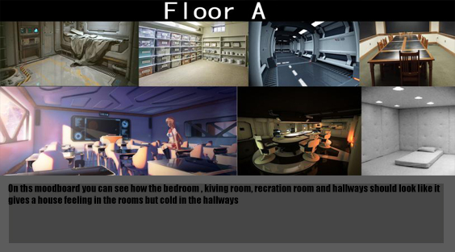This is the living area it’s Peaceful

and gives a calm feeling like you

are in a save area with no hostile

things.

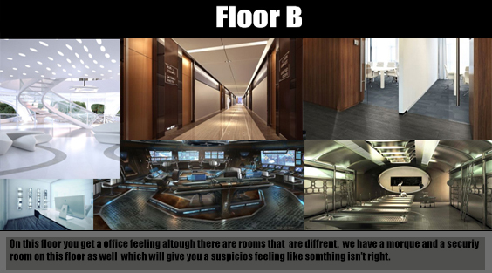

Floor B is the office area with security

and a morgue, this floor will feel like

a real company while the security will

feel like a high-tech spy room with lots

of screens.

The morgue will feel creepier and

gives you the feeling that something

here really isn’t right.

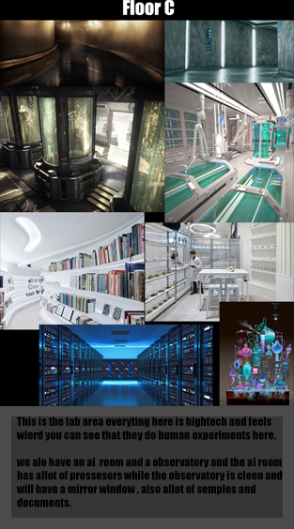This is the science area this is where all the experiments are

done, it will look futuristic and will give you the feeling

that you are not in a save area.

The AI is also down here which will be a huge server room

With allot op computers and one point to contact it.

The Poly count of the environmental assets are:

Small object: 500 polygons

Medium/ large object: < 3000 polygons

# **Characters**

# The poly count of the characters is 10.000 polygons because of the texture that is simple, the characters will have more polygons and normal baking so we can still get the details in our models and their personality will show in their looks which you can all see below.

# Story

The decision we make are a reflection of our pasts. Our history makes us who we are, good or bad. So what if we could change or erase the past of those who do bad and give them a second chance but this time with a better past?

For this reason [name project] got started up. Dr. [name] invented a method to erase and extract the memory of people and a way to “fix” their past. Many criminals have been tested at [name center], but no results have shown yet. Even if according to reports progression is made, no one knows if it’s true as what happens inside [name center] stays there.

# Characters

All images are simply an idea of what they -might- have looked like before the brain altering. It’s an inspiration but definitely not final. Same goes for information, mere suggestions and inspiration.

## C:\Users\hihim\AppData\Local\Microsoft\Windows\INetCache\Content.Word\d98a14584c50017a3f40d3bc0c612c75.jpgThe scientist

### Role

Scientist, main character.

### Personality

Depends on the player.

### History

He and his wife had a lovely son at one point, but due to his busy life as a scientist he had to leave his family very often. He worked on the alteration of the mind. He tried to fix problems in the brain such a dementia, forgetfulness, etc. to make sure humanity could become better and better over time.

With his busy work he left his wife alone with their son who had a hard time with his father being away all the time, but not as much trouble as his wife had with it. She felt so lonely she couldn’t remain loyal to her husband. His son was disgusted by his mother’s behavior but accepted it most of the time, but one night his son and wife got into a fight where his son ended up murdering his own mother. The scientist came back home to find his wife murdered and his son feeling no remorse whatsoever to what he had done. His son was now taken to prison to spent the rest of his life there.

Heartbroken with the loss of his family he was determined to get at least his son back, but this time be there for him. But he too was disgusted by the lack of remorse with his own son. He solved this dilemma by setting up the project. If he could ‘reset’ his son, if he could make him start over but this time shape him to a good person, then he could be set free and he could have at least a part of his family back.

And thus the project was created, he assembled a team of doctors and assistants to help him, and he made his greatest assistant of all time, the AI. The center was build and there his project started. He tested his methods on many criminals, improving his method over time, before finally putting it on his son. But halfway in the process complications formed and his son died. He had now successfully been the cause of both the death of his wife and his son, and he would rather forget it all. He ordered his AI assistant to use the method on him, as he wanted to start all over again.

### In the game

After him putting the method on himself the government ordered for the project to be shut down. Most doctors and assistants have been removed from the center and only a few clients remain there, him included. He will have to rediscover everything in a place/system that has been shut down and is turning into nothing but chaos.

## C:\Users\hihim\AppData\Local\Microsoft\Windows\INetCache\Content.Word\bccf02a28ae6bb0b31370a75f9c34a85.jpgDoctor

### Role

Doctor, head of the center

### Personality

Intelligent, sweet unless you cross her path

### History

The job in the center is the first she got after finishing her study. She joined from the perspective of wanting to make the world a better place, which was an innocent way to think.

### In the game

Her innocent mentality seems to have changed around 180 degrees. She learned to use her intelligence to get herself out of anything and she is someone you don’t want to cross when she’s angry. She has gone from innocent to a fucking bad ass bitch, even if she keeps her innocent look to deceive people.

## C:\Users\hihim\AppData\Local\Microsoft\Windows\INetCache\Content.Word\94dfef72e565c1c6d33e8e90af1c2147.jpgAssistant 1

### Role

Assistant, Only person left that’s good at fighting the clients if needed.

### Personality

Stern, harsh, cold, strict.

### History

Former medic in the military, injury in his eye so he couldn’t be in the military anymore.

### In the game

An assistant at the center due to his experience with fighting as well as medical experience.

## C:\Users\hihim\AppData\Local\Microsoft\Windows\INetCache\Content.Word\52289d2a8e84a1c6bed392fe28b3a48a.jpgAssistant 2

### Role

Assistant, very smart, good with tech, loyal to the scientist.

### Personality

Witty, impersonal, favors the scientist over other ‘clients’.

### History

This is the first job she took on after finishing her study, she has been working here for many years and grown up a lot during that time. She has always been rather cold and heartless with little sympathy for the clients.

### In the game

She will still have the heartless attitude towards everyone, except the scientist. She favors him and even though they have quite an age gap, she wouldn’t mind actually being with him. Him putting the method on himself broke her heart a little.

## Ai

### Role

AI, assistant, ‘god’ in the center.

### Personality

None, it’s a computer. But her program made her smart and putting orders above everything.

### History

Created by the scientist, the Ai basically always listened to him.

### In the game

Assistant 2, who is good with tech, can change the AI’s orders. The AI will be the building and surroundings and the voice that is always there, good and bad. The AI is conflicted as her programming tells her to 1 always obey her creator but, 2 never obey a client. What will it do when the scientist is both?

## C:\Users\hihim\AppData\Local\Microsoft\Windows\INetCache\Content.Word\9b166db4873852797dacea1b30203852.jpgClient 1

### Role

Old client that’s a bit crazy

### Personality

Twisted, strange, hard to make sense off

### History

Barely anyone remembers who he was before becoming part of the project. The record says he was a serial killer who got his face messed up the day he got caught. He is one of the first 30 clients and has been there ever since. They don’t know how he survived this long. He’s had countless of procedures, so many that by now he has been starting to become mad. He is hearing, seeing and knowing things others don’t.

### In the game

He will be the cloud coo-coo lander, the one that does so many things that seem illogical to most, but somehow it always makes him survive everything. He is also completely aware of the main character’s true identity, as the only one.

## C:\Users\hihim\AppData\Local\Microsoft\Windows\INetCache\Content.Word\7f371aac0cb279fbf00e09541c0eea04.jpg

## Client 2

### Role

Client, angry dude.

### Personality

Angry very quickly, just a bad person to the bone, asshole.

### History

He grew up in a rich family, getting whatever he wanted. His love was bought and nothing else. He was spoiled and heartless and his lack of emotion, except anger, would scare anyone. One time he got in a fight with one of his many girlfriends and ended up killing her, and with that he found a new interest in his life. Until he got caught and send straight to the project.

### In the game

He is the character who will go from a clueless person to a bloodthirsty killer again, it’s in him and would have outed no matter his past. However, in the beginning his strength can be use to your benefit if you know what to tell him.

## C:\Users\hihim\AppData\Local\Microsoft\Windows\INetCache\Content.Word\ec6c8f6c2e5839ab453560377ba39c0c.jpgClient 3

### Role

Client, hacking, very intelligent girl.

### Personality

Cheerful, fun loving, kind, bubbly, dangerous.

### History

There are always these kids you hear of that achieve great things in life, and there you are sitting, in your 20’s and you haven’t done anything with your life. But back to the kids, she is one like that. She grew up in a highly technological world and learned how to manipulate it like no one else, until she got caught and locked up for her cyber crimes.

### In the game

She is somehow able to stay positive in this whole mess, maybe because she still has most of her memory. She was able to manipulate the computers that put the procedure on her. Now she spends her days goofing around in a highly technologically advanced place while performing in a play all day. However, when shit hits the fan and she has to face an issue without her trusted tech, she’s more then afraid and you wonder why she’s here at all.

## C:\Users\hihim\AppData\Local\Microsoft\Windows\INetCache\Content.Word\c3aaab8408973aa958ed179372c7274f.jpgClient 4

### Role

Client, fearless one

### Personality

Badass, fearless, maybe a bit crazy

### History

There are crazy people, and then there are those dubbed crazy for their fearlessness and recklessness. This woman is the latter. Limits? She doesn’t know them. Fear? Never heard off.

### In the game

You can maybe take the bad out of her, but you can’t take the crazy out of her. Even though she has no clue who she is and where she is, she is never even bothered by it. She lets it all happen but when needed, she will do what she must without a second of doubt.

## C:\Users\hihim\AppData\Local\Microsoft\Windows\INetCache\Content.Word\7cc4d537050616a16c03b427534df7af.jpg

## Client 5

### Role

Client, motherly type

### Personality

Caring, motherly, once you touch her kids/family you’re dead.

### History

She got arrested for murder after killing to protect her children. Now getting her memory erased didn’t even seem that bad to her as it meant that she could forget ever having lost her children.

### In the game

You can take away her memory, but inside she’s still that warm loving person. She’s the comfort and the motherly type for all the prisoners, only very few don’t like her. Even the doctor has gets along with her.

## C:\Users\hihim\AppData\Local\Microsoft\Windows\INetCache\Content.Word\b7c01e8319a03c13071683d15129eb57.jpgClient 6

### Role

Client, protector, ready to sacrifice.

### Personality

Tough dude, cares little about himself

### History

He always was a rebel, he did many bad things but always for the right reason. When he got caught he accepted it without struggle.

### In the game

Even now his memory is wiped, he has a good sense of justice and is ready to sacrifice himself any moment for the right person or cause.

## C:\Users\hihim\AppData\Local\Microsoft\Windows\INetCache\Content.Word\abfebcb53950bb4362cea772c4bdd4a8.jpg

## Client 7

### Role

Client, creep however smart and needed.

### Personality

Strange, creepy, definitely something wrong with him, yet needed to survive.

### History

He had a criminal record larger then most, but he managed to play himself off as an innocent person for too long. Fraud might as well have been his last name as he knows how to manipulate almost anything. His brain reset had worked but he managed to use the young hacker to get most of his memory back.

### In the game

He will be a person that somehow is able to bend some things and he seems to be able to use everyone to his own benefit. If you have him as a friend it may help you a lot, but if he goes down, count on it he’ll take you with him.